(Wrong logo inserted this is on tap to open one )
Change the logo everywhere logo is wrong
Add ganesh photo insead of shree

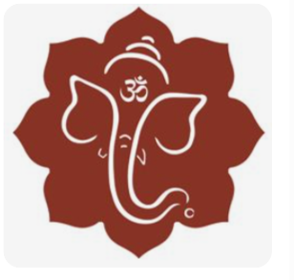
(check the spelling in sholk)
વક્રતુંડ મહાકાય સૂર્યકોટી સમપ્રભ /
નિર્વિઘ્નં કુરુ મે દેવ સર્વકાર્યેષુ સર્વદા ॥
(add something showing that one has to scroll)

(change logo)

SAPTABANDHAN CONCEPT
Our wedding journey unfolds in seven sacred chapters beginning with the decision to celebrate our lotus-like souls' union with all of you in the Kankotri-lekhan. The groom and his family then introduced the bride to their customs and bound the souls in a “sacred wedding knot” during the Chundadi Function followed by the fragrant, love-filled waves of the Mehndi celebration to both families. We then sought auspicious planetary blessings to direct us through life, like the North Star with the auspicious Grah Shanti before we go back to our roots, where all near and dear ones bless us Infinity with health and prosperity through the customary healthy Haldi. In the penultimate stage, all of us gather under the stars to dance and celebrate to the moon and back in Sangeet Night leading finally to the ultimate Vivah, where Agnidev witnesses and blesses our eternal union.

SEQUENCE OF ELEMENTS
LOTUS,the sacred knot,waves,the north star,infinity,sunmoon,agni
(in each pages as well add logo according to the event description)

REMOVE CONCEPT PAGE
REMOVE KANKOTRI AND MATAJI FROM HERE BUT MAKE 2 PDF FOR IT.(ONE FOR KAKOTRI AND ONE FOR MATAJI NA LOTA.

NAME OF THE EVENT: Chundadi – The Royal Life
- DESCRIPTION AT THE END OF THE PAGE:
A royal introduction and welcome of the bride into the family fold and customs in a larger-than-life fashion. The customary “sacred wedding knot” binds the souls together.

NAME OF THE EVENT: Mehndi – The Garden of Love
- DESCRIPTION AT THE END OF THE PAGE:
The love story unfolds as henna adorns and beautifies the bride and all the magnificent guests who come in waves to bless the bride and groom.
NAME OF THE EVENT: Grah Shanti – The sacred blessings of all planetary Gods
- DESCRIPTION AT THE END OF THE PAGE:
- The couple seeks blessings of all the celestial bodies and protection and guidance in life, just as sailors seek direction from the “North Star”.
NAME OF THE EVENT: Haldi – The roots of Love / Love stems stronger
- DESCRIPTION AT THE END OF THE PAGE:
- Love stems stronger and bonds of relations deepen like the roots during this ceremony, where all relatives bless the couple with “Infinity” in love, health, prosperity and married life.
NAME OF THE EVENT: Sangeet – Walking to the moon
- DESCRIPTION AT THE END OF THE PAGE:
- It is probably the peak of festivities where everyone celebrates with music in our galaxy, right among “the Sun and the Moon”, balancing their energies.
NAME OF THE EVENT: Wedding – Eternity
- DESCRIPTION AT THE END OF THE PAGE:
- The souls unite again in their eternal journey and vow togetherness in the presence of the most efficient purifiers – “The Agni”. The bond continues…

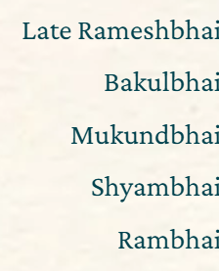
ADD MR IN FRONT OF NAMES IN THE LAST PAGE
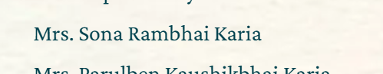
ADD BEN AFTER SONA.

